Link youtube: https://www.youtube.com/watch?v=urSWbyAbjVk&list=PLWMdLTu9kHLqTuq6yDrCiTJMxYFWM0r3r&index=1
Tutorial : https://www.tutofox.com/spring/crud-spring-boot-reactjs-api-rest-mysql-1-starter/

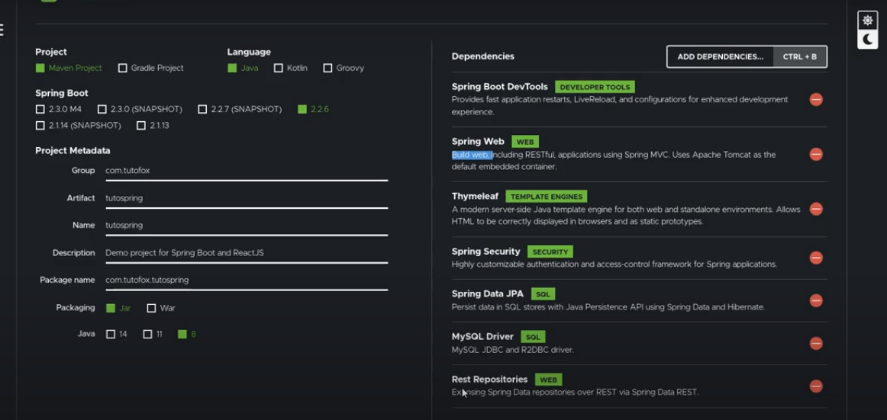

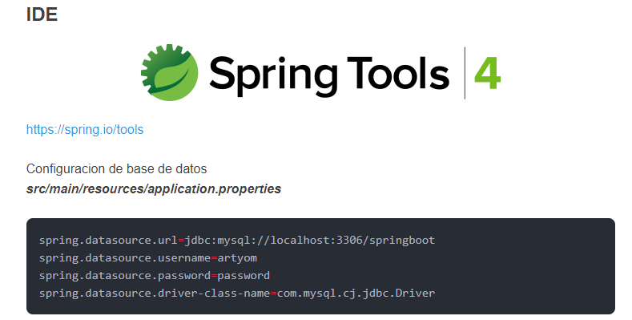
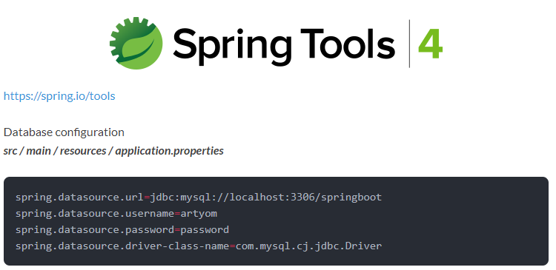

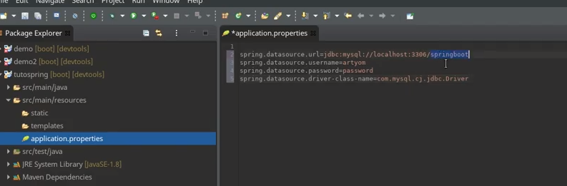
Model and View trong Spring Boot
https://levunguyen.com/laptrinhspring/2020/04/09/model-modlemap-modelview/
https://www.baeldung.com/spring-mvc-model-model-map-model-view
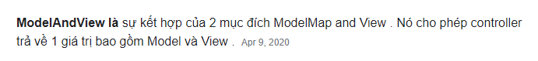

****************************************
Chỉnh XAMPP với password: 12345
https://nhat.dev/thu-thuat/cach-tao-mat-khau-root-cho-phpmyadmin-xampp.html

